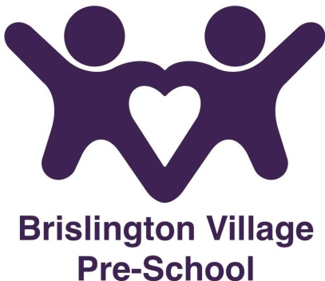
Risk Assessment Policy
Statement of Intent
Brislington Village Pre-school believes that the health and safety of the children is of paramount importance.
Aims
We will make our pre-school a safe and healthy place for children, parent/carers, staff and visitors by assessing and minimising the hazards and risks to enable the children to thrive in a healthy and safe environment.
Methods
We will follow a risk assessment procedure based on five steps.
Identification of the risk: Where is it and what is it?
Who is at risk: Staff, children, parent/carers or visitors.
Assessment of level of risk – high, medium, low. Both the risk of the likelihood of it happening, as well as the possible impact if it does.
Control measures – introduced to reduce/eliminate risk – what will you need to do, or ensure others will do to reduce the risk.
Monitoring and review – How do we know if what was said is working or is through enough? If it is not working, it will be amended or maybe there is a better solution.
Staff are required to assess the setting before each session and report any issues to the leader of the day. All staff will be made aware of any concerns.
A full risk assessment, including fire risk assessment, will be carried out annually and then updated as and when necessary throughout the year.

This policy was adopted on the 1st September 2015

Reviewed September 2023

This policy should be read in conjunction with our
Health and Safety policy
Manual Handling policy

Although under constant review, an overall review date has been set for September 2024

