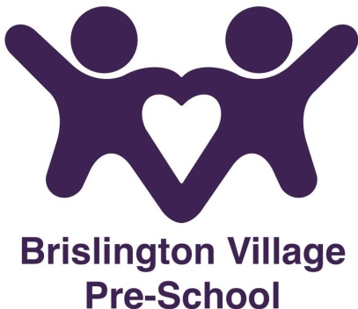
Promoting British Values policy
Statement of Intent
The DfE (Department of Education) have reinforced the need “to create and enforce a clear and rigorous expectation on all schools to promote the fundamental British Values of democracy, the rule of law, individual liberty and mutual respect and tolerance of those with different faiths and beliefs”.
At this setting we understand that the society we live in is diverse and therefore, our curriculum and life within the setting reflects this.
Aims
We aim to uphold and teach all our children about British Values which are defined as:
- Democracy
- Rule of Law
- Individual liberty
- Mutual respect
- Tolerance of those of different faiths and beliefs
Democracy
Children are always listened to by adults and are taught to listen carefully and with concern to each other, respecting the right of every individual to have their opinions and voices heard. Children also have the opportunity to air their opinions and ideas and have their voices heard through small group and circle time.
Rule of Law
The importance of rules, whether they be those that govern the setting, or the country are consistently reinforced throughout regular pre-school days, as well as when dealing with behaviour. The children are aware of the consequences of not following the rules in their pre-school. The children learn to understand the difference between right and wrong in all aspects of pre-school life and in the wider community throughout the sessions.
Individual liberty
At Brislington Village Pre-school, our children are actively encouraged to make choices, knowing that they are in a safe and supportive environment. We educate and provide boundaries for our children to make informed choices, through a safe environment and an empowering education. Our children are encouraged to give their opinions and share these ideas with due regard for the feelings of others.
Mutual Respect
Mutual respect is at the heart of our values. Children learn that their behaviour has an effect on their own rights and those of others. All members of our pre-school community treat each other with respect.
Tolerance of those of Different Faiths and Beliefs
This is achieved through enhancing children’s understanding of their place in a culturally diverse society and by giving them opportunities to experience such diversity. Members of different faiths or religions (especially parents and other family members) are encouraged to share their knowledge to enhance learning within the setting. We actively promote diversity through our celebrations of different faiths and cultures.
Prevent
Brislington Village Pre-school staff will be alert to harmful behaviour by influential people in the children’s life’s and will take action if they observe any behaviour of concern.
All staff will complete online training – Channel general awareness.

This policy was adopted on the 1st September 2015

Reviewed September 2023

This policy should be read in conjunction with:-
Behaviour management policy
Equality and Diversity policy
Race Equality policy
Safeguarding children policy
Staff Behaviour policy

Although under constant review, an overall review date has been set for September 2024

