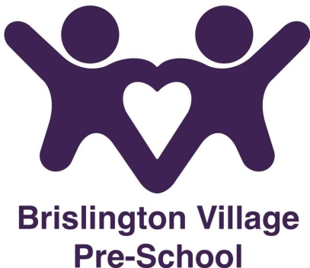
Hygiene policy
Statement of Intent
Brislington Village Pre-school staff will be vigilant to all potential threats to good hygiene within the setting.
Aims
Brislington Village Pre-school will ensure that the environment within the setting will always be hygienic. We are committed to taking all practicable steps to prevent and control the spread of infection and to uphold high standards of personal hygiene.
Methods
Practitioners’ will maintain a high standard of personal hygiene when administering any first-aid treatment.
Toilets will be checked daily and cleaned as necessary. There will always be an adequate supply of hand wash and drying facilities for both practitioner’s and children.
All staff will undergo food hygiene training.
Spillages of substances likely to result in the spread of infections will be dealt with rapidly and carefully. Blood, vomit, urine and faeces will be cleaned up immediately and disposed of safely and hygienically. Practitioners’ will wear disposable gloves while dealing with such incidents.

This policy was adopted at a meeting on 1st September 2015

Reviewed September 2023

Although under constant review, an overall review date has been set for September 2024

