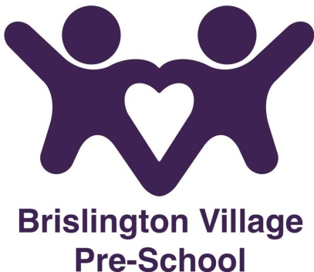

Nappy changing policy
Statement of Intent
No child will be excluded from participating in our setting who may, for any reason, not yet be toilet trained and who may still be wearing nappies or the equivalent. We will work with parents towards toilet training, unless there are medical or other developmental reasons why this may not be appropriate at the time.

Aims
We see toilet training as a self-care skill that children have the opportunity to learn with the full support and non-judgemental concern of adults.

Methods

The Pre-school has a list of which children in their care are wearing nappies or the equivalent.
The changing area we use offers privacy, is warm and has safe areas to lay young children on a changing mat for hygienic changing.
Each child has their own bag to hand with their nappies or ‘pull-ups’ and changing wipes, provided by their parents ( or provided by the pre-school for a charge). Staff will only apply non-prescription ‘over the counter’ nappy cream to a child that has been provided by the family and signed permission is given on our record of information form. If any prescription nappy rash creams are needed for the child an administration of medicine form must be completed. (In the absence of their own belongings the pre-school has a small emergency supply).
Gloves and aprons are put on before changing commences, and the areas are prepared. The changing mat is cleaned with antibacterial wipes before and after the mat is used and a clean paper sheet is used for each child.
All staff are familiar with the hygiene procedures, and carry these out when changing nappies.
In addition, staff ensure that nappy changing is relaxed and at a time to promote independence in young children.
The children are encouraged to wash their hands after having their nappy changed to prepare them for the routine.
Staff are gentle when changing nappies/pull ups; they avoid pulling faces and making negative comments about ‘nappy contents’.

A child will never be left unattended on the changing mat.
Nappies and ‘pull-ups’ are disposed of hygienically, by bagging them and putting them into a nappy bin.

When the children have had their nappy or ‘pull-up’ changed a nappy changing record sheet will be completed and signed and dated.

This policy was adopted on 4th February 2019

Reviewed September 2023

This policy should be read in conjunction with our:-

Administration of Medication policy

Although under constant review, an overall review date has been set for September 2024

