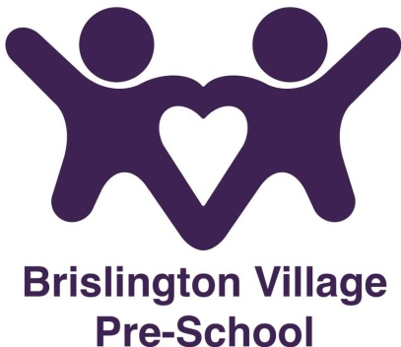
Asthma Policy
Statement of Intent
Brislington Village Pre-school recognises that asthma is a widespread, serious but controllable condition that affects many children.
Aims
This setting encourages children with asthma to achieve their potential.
Methods
- Inhalers will be kept safely but readily available within the setting.
- Parents/carers are asked to ensure that a spare labelled inhaler is provided to the setting.
- Parents are asked to complete an administration of medication form and/or a medical care plan detailing how and when the medication should be taken.
- A medication form will be completed and signed by a member of staff and a parent every time a child has their asthma medication.
- Brislington Village Pre-school staff are not required to administer asthma medicine to children (except in an emergency); however staff may choose to volunteer to administer medication.
- Staff will receive the necessary training to enable them to administer medication.
- Children with asthma are encouraged to participate fully in any physical activities.
- When children with asthma go on a trip, the setting will make sure that there is at least one member of staff who has had relevant training.
- Brislington Village Pre-school will ensure that the children have their asthma medication when they participate in a trip.

This policy was adopted at a meeting on 1st September 2015

Reviewed September 2023

This policy is to be read in conjunction with our:-
Administration of Medication policy
Health and safety policy

Although under constant review, an overall review date has been set for September 2024

