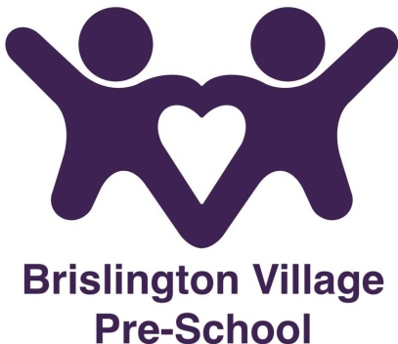

Zero Tolerance for Harassment Policy
Statement of Intent
Brislington Village Pre-school recognises its responsibility to provide a safe and healthy working environment.
Aims
Our staff work positively towards developing a positive working partnership with parents, carers and extended family members of the children in our care.
Methods
Occasionally persons may choose not to follow the existing procedures and protocols when they believe they have a concern or an issue and choose to respond in a negative, hostile or intimidating manner towards our staff. We have a statutory obligation to ensure the provision is a safe and secure environment for all of our children and staff.

Violence towards staff is a crime – The Management will press for maximum penalty for any person who behaves in a violent or abusive
way towards our staff.

Abusive or Violent Behaviour

Any incident that occurs where staff, parents, volunteers or visitors commit an act of violence against any member of staff or other person, or behave in such a way that any such person fears for their safety will be reported to the police immediately. We reserve the right to terminate any pre-school booking with immediate effect, there will be no appeal process in such instances and relevant authorities will be contacted to include OFSTED, the Local Authority and relevant safeguarding agencies.

Expected Standards of Behaviour

We have a duty to provide a safe and secure environment for staff, children and visitors. Violent, abusive or harassing behaviour will not be tolerated and decisive action will be taken to protect staff and children.

Harassment is defined as any unwanted physical or verbal conduct that offends, hurts or humiliates the recipient, that interferes with their ability to work and learn or leads to adverse job-related consequences, and that any reasonable person ought to have known would be unwelcome. It does not include the legitimate exercise of supervisory authority regarding performance reviews, work evaluations, or valid disciplinary measures. Examples of harassment include, but are not limited to, racial or sexual slurs, name calling, racist or sexist jokes, negative stereotyping, physical assault, bullying, threats, demeaning pictures, posters and graffiti. Harassment includes the following categories of behaviour, whether the behaviour occurs once or on repeated occasions.

- Discriminatory behaviour
Discrimination refers to treating people differently, negatively, or adversely because of one or more of the following prohibited grounds of discrimination: race, colour, ancestry, place of origin, political belief, religion, age, sex, sexual orientation, marital status, family status, physical or mental disability, or pardoned criminal conviction.

- Personal harassment
Personal harassment includes objectionable conduct, comment, or display made on either a one-time or continuous basis that demeans, belittles, or causes personal humiliation or embarrassment on the part of the recipient. It may or may not be linked to discriminatory behaviour.

- Sexual harassment
Sexual harassment refers to any conduct, comment, gesture, or contact of a sexual nature, whether on a one-time basis or a series of incidents, that might reasonably be expected to cause offence or humiliation or that might reasonably be perceived as placing a condition of a sexual nature on employment, an opportunity for training or promotion, receipt of services, or a contract. Examples of behaviour that can constitute sexual harassment include, but are not limited to:

- unwanted touching, patting or leering
- sexual assault
- enquiries or comments about a person’s sex life
- telephone calls with sexual overtones
- gender-based insults or jokes causing embarrassment or humiliation
- repeated unwanted social or sexual invitations
- inappropriate or unwelcome focus/comments on a person’s physical
- attributes or appearance

- Bullying
Bullying consists of behaviour to attack and diminish another by subjecting the recipient to unjustified criticism and trivial fault-finding, humiliating the recipient (especially in front of others).

Behaviours unacceptable on our pre-school premises include but are not limited to:

- Screaming, shouting and loud intrusive conversation
- Malicious allegations towards other parents, staff or visitors
- Threats or threatening behaviour
- Offensive language
- Intimidating behaviour – verbal or non-verbal
- Harassment
- Bullying towards staff
- Wilful damage to nursery property or environments
- Theft
- Violence towards persons or property
- Derogatory, sexist racist remarks

Any such instances must be reported to the Senior Management team who will support the staff member. Any such incident must be fully recorded on an incident form as well as a written report being completed. All witnesses must write a statement detailing what was observed / heard. The Management will ensure all relevant authorities are informed and support the staff member with reporting the incident to the Police.

This policy was adopted at a meeting of Brislington Village Pre-school on 7th November 2016.

Reviewed September 2023

This policy should be read in conjunction with our

Anti-Bullying policy
Whistleblowing policy

Although under constant review, an overall review date of September 2024 has been set.

