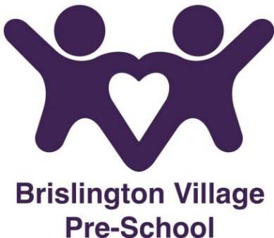

Sickness Policy

Our policy on excluding ill or infectious children is discussed with parents. This includes procedures for contacting parents - or other authorised adults - if a child becomes ill while in the setting.
- We do not provide care for unwell children, those who have a temperature, or sickness and diarrhoea, or who have an infectious disease. If a child has been given a dose of any pain relief medication on the day they are due at the setting, they are unable to attend pre-school that day.
- In the event of a temperature, we ask that children be kept home for 48 hours to help with infection control
- If your child has been given antibiotics, then they cannot attend pre-school for the first 48 hours of taking the antibiotics.
- In line with health department guidelines, parents with children suffering from diarrhoea and or vomiting are advised to keep their children at home for a further 48 hours from when symptoms clear. This is to aid recovery and minimise the spread of infections.
- Children with head lice are not excluded but must be treated to remedy the condition.
- Parents are notified if there is a case of head lice in the setting.
- Parents are notified if there is an infectious disease, such as chicken pox.
- Hand, foot, and mouth are highly contagious. Children showing symptoms of Hand, Foot, and Mouth will need to be kept home from preschool for 5 days, and until blisters/spots have scabbed over.
- HIV (Human Immunodeficiency Virus) may affect children or families attending the setting. Staff may or may not be informed about it.
- Children or families are not excluded because of HIV.
- Good hygiene practice concerning the clearing of any spilled bodily fluids is carried out at all times.
- We will notify Ofsted of any serious and notifiable illnesses. We will do this within 14 days and understand that Ofsted may take action against us if we don’t. We will use the following form to notify them (https://www.gov.uk/guidance/report-a-serious-childcare-incident)
- We will also notify Public Health England.
Avon, Gloucestershire and Wiltshire HPT
(Health Protection Team)
Public Health England South West
2 Rivergate
Redcliffe
Bristol
BS1 6EH
Tel: 0300 3038162

Link to notifiable diseases
(htps://www.gov.uk/guidance/notifiable-diseases-and-causative-organisms-how-to-report-list-of-notifiable diseases

