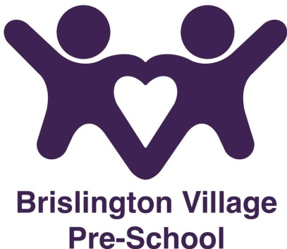
Sleep/Rest Policy
Statement of Intent
Brislington Village Pre-school understands that sleep/rest is fundamental to the young children because sleep deprivation impacts negatively on the mental, physical and emotional health of the child and their whole family.
The pre-school will give the children the opportunity to rest/sleep appropriate to their age/stage of development and their individual needs. The individual sleep/rest pattern of children will be discussed before they start at the pre-school and agreed with parents/carers and met as far as possible within the daily routine.
Aims
The pre-school will provide a comfortable area and appropriate environment to allow children to rest as and when they wish to throughout the day.
Methods
The pre-school will discuss the sleeping patterns of the child at the home visit before they begin at the pre-school.
The sleeping area in the setting will be calm and not over-stimulating and we will work in partnership with families to offer their child a sleep routine that is as consistent as possible.
Parent/carers permission will be sought on our record of information form if your child sleeps in their pram/buggy.
Sleeping children will be checked at least every 5 minutes and a sleep chart filled out to say this has been done.
All bedding will be clean and in good condition and suited to the age of the child. Bedding must not be shared without being washed.

Reviewed September 2023

This procedure was adopted at a meeting on 19th February 2018

Although under constant review, an overall review date has been set for September 2024

